School of the Word

God’s First Chosen People: their story and ours
3. The Torah / Pentateuch

Kieran J. O’Mahony, OSA
www.tarsus.ie

Programme
- Gospel
- First Reading
- Second Reading

Detailed Programme
- The Old Testament in our faith and worship
- The use of the Old Testament in the readings
- The Torah / Pentateuch
- A literary history of the Bible / Israel
- Praying the Psalms
- Justice: the prophetic voice

Sequence
- Torah
- What’s in the Torah
- Origins of the Torah
- Reading the Torah
- Praying the Torah
- Conversation

The Torah
- The Five Books of Moses
- For Jews, the heart of the Bible
- “Torah” means Instruction / Teaching / Law (Hebrew)
- Pentateuch means a “Five book work” (Greek)

What’s in the Torah?
- Genesis, Exodus, Leviticus, Numbers, Deuteronomy
- Always treated with great respect
- Fundamentally, it tells 3 sets of stories:
- The Pre-history from Adam to Noah (Gen 1-11)
- Stories of Abraham, Jacob and Joseph (Gen 12-50)
- The Moses stories (Ex, Lev, Num Deut)

Adam to Noah
- Creation stories 1 and 2
- The Fall
- The children of Adam and Eve
- Noah and the Flood
- The Tower of Babel

Then God said, “Let us make humankind in our image, according to our likeness; and let them have dominion over the fish of the sea, and over the birds of the air, and over the cattle, and over all the wild animals of the earth, and over every creeping thing that creeps upon the earth.” So God created humankind in his image, in the image of God he created them; male and female he created them. God blessed them, and God said to them, “Be fruitful and multiply, and fill the earth and subdue it; and have dominion over the fish of the sea and over the birds of the air and over every living thing that moves upon the earth.” (Gen 1:26–28)
Abraham to Joseph
- Abraham stories
- (Isaac)
- Jacob stories
- Joseph stories

After these things the word of the Lord came to Abram in a vision, “Do not be afraid, Abram, I am your shield; your reward shall be very great.” But Abram said, “O Lord God, what will you give me, for I continue childless, and the heir of my house is Eliezer of Damascus?” And Abram said, “You have given me no offspring, and so a slave born in my house is to be my heir.” But the word of the Lord came to him, “This man shall not be your heir; no one but your very own issue shall be your heir.” He brought him outside and said, “Look toward heaven and count the stars, if you are able to count them.” Then he said to him, “So shall your descendants be.” And he believed the Lord; and the Lord reckoned it to him as righteousness. (Gen 15:1–6)

The Book of Exodus
1: 1–15: 21: Exodus from Egypt
15: 22–18: 27: Israel’s journey through the desert to Mount Sinai
19: 1–24: 11: Yahweh makes a covenant with Israel at Mount Sinai
24: 12–31: 18: The Ten Commandments
32: 1–34: 35: The Golden Calf
35: 1–40: 38: The building of the Tabernacle

Moses was keeping the flock of his father-in-law Jethro, the priest of Midian; he led his flock beyond the wilderness, and came to Horeb, the mountain of God. There the angel of the Lord appeared to him in a flame of fire out of a bush; he looked, and the bush was blazing, yet it was not consumed. Then Moses said, “I must turn aside and look at this great sight, and see why the bush is not burned up.” When the Lord saw that he had turned aside to see, God called to him out of the bush, “Moses, Moses!” And he said, “Here I am.” Then he said, “Come no closer! Remove the sandals from your feet, for the place on which you are standing is holy ground.” He said further, “I am the God of your father, the God of Abraham, the God of Isaac, and the God of Jacob.” And Moses hid his face, for he was afraid to look at God.

But Moses said to God, “If I come to the Israelites and say to them, ‘The God of your ancestors has sent me to you,’ and they ask me, ‘What is his name?’ what shall I say to them?” God said to Moses, “I AM WHO I AM.” He said further, “Thus you shall say to the Israelites, ‘I AM has sent me to you.’” God also said to Moses, “Thus you shall say to the Israelites, ‘The Lord, the God of your ancestors, the God of Abraham, the God of Isaac, and the God of Jacob, has sent me to you’: This is my name forever, and this my title for all generations. (Exod 3:13–15)

The Book of the Leviticus
- Leviticus 1 – 10 Sacrifices etc.
- Lev 11 –16: Purity Laws
- 17–26 (+27), The Holiness Code

The Lord spoke to Moses, saying: Speak to all the congregation of the people of Israel and say to them: You shall be holy, for I the Lord your God am holy. (Leviticus 19:1–2)

You shall not render an unjust judgment; you shall not be partial to the poor or defer to the great: with justice you shall judge your neighbor. (Leviticus 19:15)

You shall not take vengeance or bear a grudge against any of your people, but you shall love your neighbor as yourself: I am the Lord. (Leviticus 19:18)

You shall keep my statutes. You shall not let your animals breed with a different kind; you shall not sow your field with two kinds of seed; nor shall you put on a garment made of two different materials. (Leviticus 19:19)

You shall not eat anything with its blood. (Leviticus 19:26)

You shall rise before the aged, and defer to the old; and you shall fear your God: I am the Lord. (Leviticus 19:32)

The Book of Numbers
- Numbers 1: 1 – 10: 28, Establishing a Holy Community
- Numbers 11: 1 – 20: 28, In the Wilderness
- Numbers 21: 1 – 36: 13, Conquest and Settlement of the Land

So Moses took the staff from before the Lord, as he had commanded him. Moses and Aaron gathered the assembly together before the rock, and he said to them, “Listen, you rebels, shall we bring water for you out of this rock?” Then Moses lifted up his hand and struck the rock twice with his staff; water came out abundantly, and the congregation and their livestock drank. But the Lord said to Moses and Aaron, “Because you did not trust in me, to show my holiness before the eyes of the Israelites, therefore you shall not bring this assembly into the land that I have given them.” These are the waters of Meribah, where the people of Israel quarreled with the Lord, and by which he showed his holiness. (Numbers 20:9–13)

Gen – Ex – Lev – Num - Deut
- Adam to Noah (Genesis 1-11)
- Abraham to Joseph (Genesis 12-50)
- Moses (Exodus, Leviticus, Numbers, Deuteronomy)

- Adam to Joseph in Egypt: Genesis
- Exodus to Entry – forty years: Exodus
- Mt Sinai, the wandering in the desert, legislation, coming within sight of the land: Exodus, Leviticus, Numbers
- The last will and Testament of Moses: Deuteronomy

Kind of Writing
- Myth
- Family Saga
- Wisdom
- Poetry
- “Etiological stories”
- Laws
- Ten Commandments

Origins of the Torah
- The Torah was written over many centuries
- It began as oral tradition, later written down
- It reflects different contexts
- It was edited and brought “up to date”
- Parts are historical
- Parts are mythological
- There is a good deal of laws

- Language of Genesis 1: “Elohim” (E)
- Language of Genesis 2-3: “Yahweh” (J)
- Language of Leviticus: Priestly (P)
- Language of Deuteronomy: Deuteronomistic (D)

Date | Sources
? | Oral traditions
c. 922 | J (South)
c. 850 |  |  | E (North)
c. 722 |  | JE
c. 600 | D (Israel)
c. 539 |  |  | P (Babylon)
c. 400 |  | JEPD

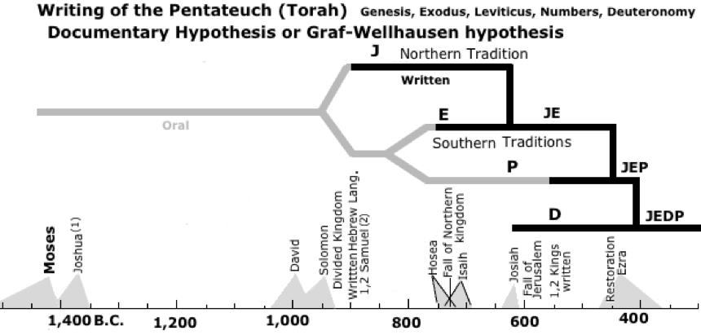
Important Passages
GENESIS: 1-3 (creation and fall); 6,5 - 9,17 (flood); 12,1-3 (call of Abraham); 15 (covenant with Abraham); 18,1-15 (vision at Mamre); 22,1-19 (the sacrifice of Isaac); 28,10-22 (vision at Bethel); 32,23-33 (Jacob’s struggle with the “angel”); 37 (Joseph sold by his brothers); 45,1-13 (Joseph makes himself known to his disciples); 50,15-31 (Joseph and his brothers are reconciled).

EXODUS: 2,1-10 (birth of Moses); 3,1-15 (3,1 - 4,17) (call of Moses); 7,1 - 10,11; 12,29-36 (the plagues in Egypt); 14,1-31 (crossing the Red Sea); 19,1-19 (appearance at Sinai); 20,1-17 (Then Commandments); 24,1-11 (covenant on Sinai); 32-34 (the Golden Calf; renewal of the covenant).

LEVITICUS: 19,1-19 (“Be holy as I am holy”).

NUMBERS: 13-14 (Exploration of the Promised Land); 22-24 (Balaam).

DEUTERONOMY: 4 (the meaning of Sinai); 6,1-9 (“Shema Yisrael”); 8 (the temptations of the holy land); 30,11-14 (the word is near); 30,15-20 (the two ways).

NB: New forms of reading: chiefly cultural and narrative (to be developed).

Praying the Torah
CREATION
- Genesis 1:1-2:4a Basic story
- Psalm 104 Story in the form of prayer
- Ephesians 1:3-14 Christ and creation

REDEMPTION
- Exodus 12:1-27 The Passover
- Psalm 114 The Passover hymn
- Mark 14:12-25 The Last Supper

THE WORD IS NEAR
- Deuteronomy 30:11-14 How near is God?
- Psalm 147 God’s Word is near
- Romans 10:5-13 Nearness of God’s Word

Conversation

